# Week #6

**Designing and Simulation of Network Topology using Cisco Packet Tracer**

**SRN : PES2UG20CS237**

**Name : P K Navin Shrinivas**

**Section : D**

## Task 1 (Demo) Network Topology

## The needed topology was created as shwon in screenshots.

## IP address, gateways and routing was entered manually as shown below.

## A simple PDU was sent from one network to the other.

## The successful status of the PDU can be seen in the botton right.

**Configuration followed :**

**End systems :**

|  |  |  |  |
| --- | --- | --- | --- |
| **End System** | **IP Address** | **Subnet Mask** | **Default Gateway** |
| PC5 | 192.168.1.10 | 255.255.255.0 | 192.168.1.1 |
| PC6 | 192.168.1.11 | 255.255.255.0 | 192.168.1.1 |
| PC7 | 192.168.2.10 | 255.255.255.0 | 192.168.2.1 |
| PC7 | 192.168.2.11 | 255.255.255.0 | 192.168.2.1 |

**Routers :**

|  |  |  |  |
| --- | --- | --- | --- |
| **Router** | **Interface** | **IP address** | **Subnet Mask** |
| Router4 | GigabitEthernet0/0/0 | 192.168.1.1 | 255.255.255.0 |
| Router4 | GigabitEthernet0/0/1 | 10.0.4.1 | 255.0.0.0 |
| Router5 | GigabitEthernet0/0/0 | 192.168.2.1 | 255.255.255.0 |
| Router5 | GigabitEthernet0/0/1 | 10.0.4.2 | 255.0.0.0 |

**Routing Table :**

|  |  |  |
| --- | --- | --- |
| **Router** | **Destination** | **Next Hop** |
| Router4 | 192.168.2.0 | 10.0.4.2 |
| Router5 | 192.168.1.0 | 10.0.4.1 |

**Screenshots :**

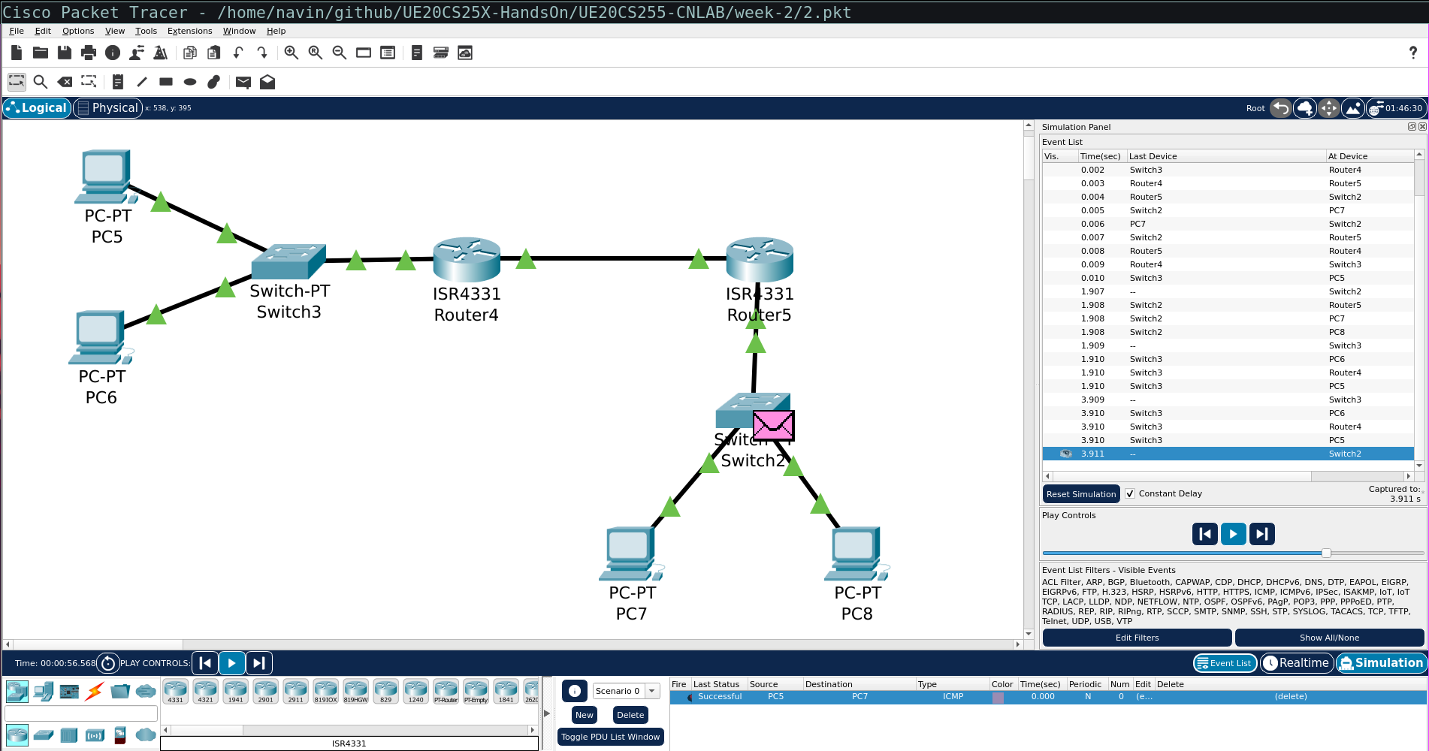

## **Task 2 (Mandatory for Week-6)**

## The needed topology was created as shwon in screenshots.

## IP address, gateways and routing was entered manually as shown below.

## A simple PDU was sent from one network to the other through another router.

## The successful status of the PDU can be seen in the botton right.

**Configuration followed :**

**End systems :**

|  |  |  |  |
| --- | --- | --- | --- |
| **End System** | **IP Address** | **Subnet Mask** | **Default Gateway** |
| PC0 | 192.168.1.10 | 255.255.255.0 | 192.168.1.1 |
| PC1 | 192.168.1.11 | 255.255.255.0 | 192.168.1.1 |
| PC2 | 192.168.2.10 | 255.255.255.0 | 192.168.2.1 |
| PC3 | 192.168.2.11 | 255.255.255.0 | 192.168.2.1 |
| PC4 | 192.168.3.10 | 255.255.255.0 | 192.168.3.1 |
| PC5 | 192.168.3.11 | 255.255.255.0 | 192.168.3.1 |

**Routers :**

|  |  |  |  |
| --- | --- | --- | --- |
| **Router** | **Interface** | **IP address** | **Subnet Mask** |
| Router0 | FastEthernet0/0 | 192.168.1.1 | 255.255.255.0 |
| Router0 | FastEthernet1/0 | 10.0.4.1 | 255.0.0.0 |
| Router1 | GigabitEthernet0/0 | 192.168.2.1 | 255.255.255.0 |
| Router1 | GigabitEthernet1/0 | 10.0.4.2 | 255.0.0.0 |
| Router1 | GigabitEthernet2/0 | 3.3.3.2 | 255.0.0.0 |
| Router2 | FastEthernet0/0 | 192.168.3.1 | 255.255.255.0 |
| Router2 | FastEthernet1/0 | 3.3.3.1 | 255.0.0.0 |

In the above table we can see one interface of Router1 is part of network 3(3.3.3.2)

**Routing Table :**

|  |  |  |
| --- | --- | --- |
| **Router** | **Destination** | **Next Hop** |
| Router0 | 192.168.3.0 | 10.0.4.2 |
| Router0 | 192.168.2.0 | 10.0.4.2 |
| Router1 | 192.168.3.0 | 3.3.3.1 |
| Router1 | 192.168.1.0 | 10.0.4.1 |
| Router2 | 192.168.1.0 | 3.3.3.2 |
| Router2 | 192.168.2.0 | 3.3.3.2 |

## **Screenshots :**

